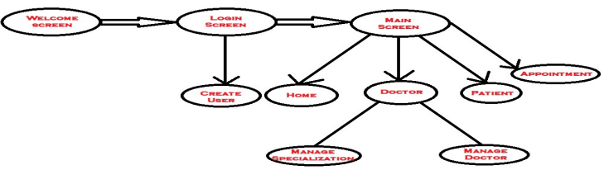

**Implementation**

The purpose is to keep the track record of Doctors, previous history of Patients, & Receptionist. This revolves around GUI based software that helps in storing, updating, and retrieving the information through various user-friendly menu-driven modules. The primary goals and purposes of this study are Create and maintain a patents database for data analysis and decision-making. In this project implementation part we have 4 modules which are Admin, doctors, Appointment and Patient.

ADMIN : this module consist of basic information showing the today’s appointment on the screen.

DOCTOR :- it keeps track of all details about the doctor’s like adding and deleting the doctor details, searching/viewing a doctor via specialization.

APPOINTMENT :- here a user can fix the appointment to a doctor they needed for therapy.

PATIENT :- it provides deleting and adding patient details, updating of patient details also provides searching for patient.

FLOW CHART OF HOSPITAL MANAGEMENT SYSTEM

**Tools/Technique :**

We have used Python IDLE , Tkinter , Messagebox , Datetime.

Mentor Name :- Dr.Sunil Gupta

**Abstract**

The purpose of the project entitled as “Hospital Management System” is to computerize the front office management of hospital to develop software which is user friendly simple, fast, and cost effective. The main function of the system is register and store patient details and doctor details and retrieve these details as and when required and also to manipulate these details meaningfully. Traditionally, it was done manually. The Hospital Management System can be entered using a username and password. It is accessible by an Admin, Doctor, & Receptionist. Only they can add data to the database. The data can be retrieved easily. The data are well protected for the personal use and makes the data processing very fast.

**Team Details**

Name :- Shivansh Sharma

Email Id :- [shivansh832.be22@chitkara.edu.in](mailto:shivansh832.be22@chitkara.edu.in)

Name :- Shiven Narang

Email Id :- [shiven835.be22@chitkara.edu.in](mailto:shiven835.be22@chitkara.edu.in)

Name :- Sneha Pal

Email Id :- sneh996.be22@chitkara.edu.in

HOSPITAL MANAGEMENT SYSTEM